UNITED STATES
SECURITIES AND EXCHANGE COMMISSION
Washington, D.C. 20549

Form 6-K

REPORT OF FOREIGN PRIVATE ISSUER PURSUANT TO RULE 13a-16 OR 15d-16
UNDER THE SECURITIES EXCHANGE ACT OF 1934

For the month of September 2026

Commission File Number: 001-43279

Micware Co., Ltd.

Kobe Asahi Building 25th Floor
59 Naniwa-machi, Chuo-ku
Kobe, Hyogo 650-0035
(Address of principal executive office)

Indicate by check mark whether the registrant files or will file annual reports under cover of Form 20-F or Form 40-F.

Form 20-F ☒ Form 40-F ☐

INFORMATION CONTAINED IN THIS FORM 6-K REPORT

On September 3, 2026, Micware Co., Ltd. (the “Company”) issued a press release announcing its new growth strategies relating to two platform businesses. A copy of the press release is furnished as Exhibit 99.1 hereto.

In connection with the press release, the Company expects to publish the attached presentation (the “Presentation”), which details the growth strategies, on its investor relations website, as well as to use it from time to time with potential investors. A copy of the Presentation is furnished as Exhibit 99.2 hereto.

Neither this report nor the exhibits attached hereto constitute an offer to sell, or the solicitation of an offer to buy the Company’s securities, nor shall there be any sale of the Company’s securities in any state or jurisdiction in which such offer, solicitation or sale would be unlawful prior to the registration or qualification under the securities laws of any such state or jurisdiction.

1

Exhibit Index

Exhibit No. |  | Description
99.1 |  | Press Release
99.2 |  | Investor Presentation

2

SIGNATURE

Pursuant to the requirements of the Securities Exchange Act of 1934, the registrant has duly caused this report to be signed on its behalf by the undersigned, thereunto duly authorized.

 | Micware Co., Ltd.
 | By: | /s/ Takuma Segawa
 |  | Mr. Takuma Segawa
 |  | Chief Financial Officer

Date: September 3, 2026

3

Exhibit 99.1

Micware Launches Growth Strategy Connecting Mobility and Digital Spaces with AI at its Core

With its two platforms “micAuto” and “DynaPlanet”, Micware aims to evolve into a
business where technology assets continuously create value

KOBE, Japan, Sept. 3, 2026 (GLOBE NEWSWIRE) – Micware Co., Ltd. (Nasdaq: MWC) (the “Company” or “Micware”), a Japan-based provider of software development services and innovative IT solutions mainly focused on the automotive and mobility sectors, today announced the launch of a platform-based growth strategy designed to convert the technologies, data, and development expertise it has accumulated through in-vehicle software development into sustained value. By positioning mobility and digital spaces as new growth domains, Micware aims to evolve from a business centered on individual development projects into one that can deploy its technology assets more broadly.

The two platforms supporting this strategy are “micAuto” in the mobility domain and “DynaPlanet,” which connects the physical and digital worlds. The strategic direction of these platforms is reflected in newly introduced logos. Micware has disclosed details of the growth strategies and key performance indicators (KPIs) for both platforms on its IR website.



Two Platforms Driving the Growth Strategy

Micware positions micAuto as a bridge that connects people, cities, and mobility through movement. The “A” in the logo represents connections expanding toward the future.

DynaPlanet is a digital three-dimensional space where people and AI intersect, and new value is created. The “D” in the logo represents a form that embraces people, things, and experiences while expanding connections.

micAuto — From Supporting OEM Development Transformation to Mobility Physical AI

micAuto is a platform that leverages in-vehicle software assets to support original equipment manufacturers (OEMs) in transforming their development processes. While maintaining its foundation in the in-vehicle infotainment system (IVI) domain, Micware plans to expand its business areas into autonomous driving (AD)/ advanced driver-assistance systems (ADAS), connected services, and quality assurance.

Looking ahead, Micware aims to realize “Mobility Physical Artificial Intelligence (AI),” in which mobility systems understand their surrounding environments and support people in a more intuitive and context-aware manner.

DynaPlanet — A Three-Dimensional (3D) Intelligence Ecosystem Supported by Three 3D Layers

DynaPlanet, the other strategic pillar, is a spatial platform that aims to connect “Real 3D Interiors,” “Real 3D Cities,” and “Virtual 3D Worlds” on a single foundation.

“Real 3D Interiors” and “Real 3D Cities” are designed to provide spatial data, licenses, and solutions for enterprises and local governments, while “Virtual 3D Worlds” will be developed as an open space in which users and creators can participate.

By addressing a broad range of applications, including interior design, urban planning, virtual worlds, and games, Micware aims to develop a digital space ecosystem in which content, users, enterprises, and creators interact and create value.

Synergies Between the Two Platforms

micAuto targets mobility moving through the real world, while DynaPlanet targets the surrounding cities and buildings.

Micware intends to promote value creation across mobility, cities, facilities, and logistics by utilizing sensor data derived from mobility for spatial generation and updates, and by applying analysis and simulations conducted in digital spaces back to real-world services.

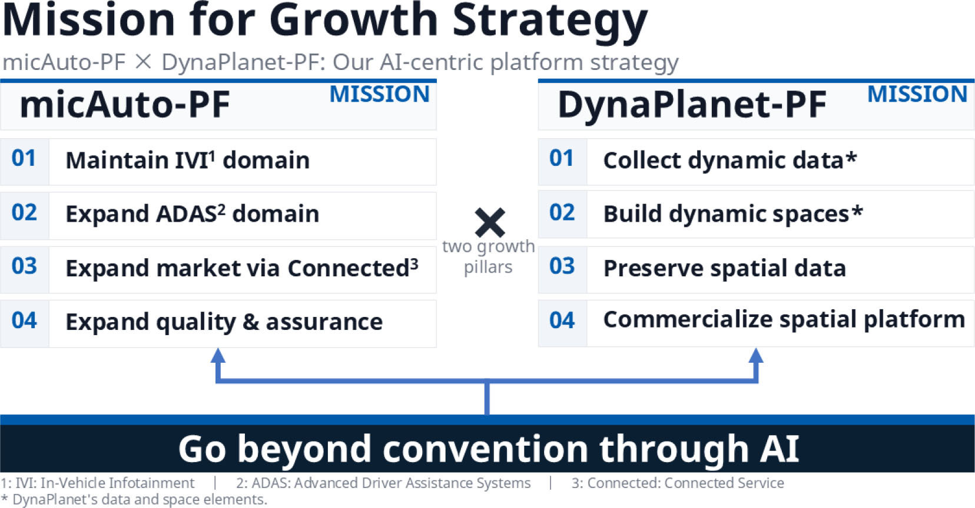

Evolution of the Business Model and Future Growth Strategy

Micware aims to implement its technologies, software, data, and development expertise as reusable assets within its platforms, and to evolve into a business structure that delivers value through services, licensing, and data provision. This represents Micware’s next stage of growth toward “Be There Be Now — toward a world that naturally inspires people to go out.”

For more information on its future growth strategy and KPIs, please visit the Company’s IR website: www.ir-micware.com.

2

About Micware Co., Ltd.

Micware Co., Ltd. is a Japan-based provider of software development services and innovative IT solutions mainly focused on the automotive and mobility sectors. The Company is primarily engaged in the development and sale of in-vehicle infotainment (“IVI”) systems covering multimedia, navigation, human machine interface, telematics, and driver assistance, as well as navigation software and location information-based smartphone applications.

Since its founding in 2003, Micware has built over 20 years of experience in automotive software and has established long-term relationships with major original equipment manufacturers (“OEM”) in Japan, including Honda and Toyota. Leveraging its engineering capabilities, proprietary technologies, and long-standing OEM relationships, the Company was ranked 9th among Japan-based Tier 1 suppliers in the IVI market in terms of revenue as of February 28, 2024, according to an industry report titled “IVI, Automotive Navigation System and Digital Mapping Market” commissioned by the Company and prepared by Frost & Sullivan. Micware operates across Japan through six operating entities and 13 branch offices and has established subsidiaries in the United States, Thailand, and Germany for overseas operations.

For more information, please visit the Company’s IR website: www.ir-micware.com.

Forward-Looking Statements

Certain statements in this press release are forward-looking statements. These forward-looking statements involve known and unknown risks and uncertainties and are based on the Company’s current expectations and projections about future events that the Company believes may affect its financial condition, results of operations, business strategy, and financial needs. Investors can find many (but not all) of these statements by the use of words such as “approximates,” “believes,” “hopes,” “expects,” “anticipates,” “estimates,” “projects,” “intends,” “plans,” “will,” “would,” “should,” “could,” “may,” or other similar expressions in this press release. The Company undertakes no obligation to update or revise publicly any forward-looking statements to reflect subsequent occurring events or circumstances, or changes in its expectations, except as may be required by law. These statements are subject to uncertainties and risks, including, but not limited to, the uncertainties related to market conditions, and other factors discussed in the “Risk Factors” section of the annual report on Form 20-F filed with the U.S. Securities and Exchange Commission (the “SEC”). Although the Company believes that the expectations expressed in these forward-looking statements are reasonable, it cannot assure you that such expectations will turn out to be correct, and the Company cautions investors that actual results may differ materially from the anticipated results and encourages investors to review other factors that may affect its future results in the annual report on Form 20-F and other filings with the SEC. Additional factors are discussed in the Company’s filings with the SEC, which are available for review at www.sec.gov.

For more information, please contact:

Micware Co., Ltd.
Investor Relations Department
Email: mic_ir@micware.co.jp

Public Relations
Email: mic_pr@micware.co.jp

Ascent Investor Relations LLC
Tina Xiao
Phone: +1-646-932-7242
Email: investors@ascent-ir.com

3

Exhibit 99.2


THE FUTURE MICWARE ENVISIONS micAuto - PF DynaPlanet - PF GROWTH STRATEGY Creating value that supports the future of society and mobility, through the synergy of two platforms September 2026 Micware Co., Ltd. (Nasdaq: MWC) ALL Rights Reserved, Copyright© Micware Co., Ltd. 2026

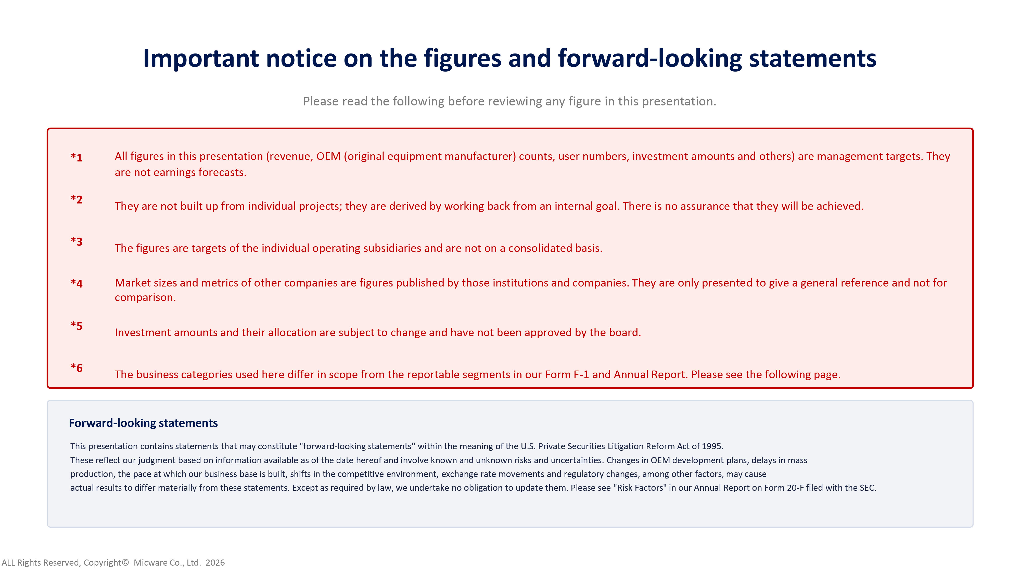
Important notice on the figures and forward - looking statements Please read the following before reviewing any figure in this presentation. *1 All figures in this presentation (revenue, OEM (original equipment manufacturer) counts, user numbers, investment amounts and ot hers) are management targets. They are not earnings forecasts. *2 They are not built up from individual projects; they are derived by working back from an internal goal. There is no assurance th at they will be achieved. *3 The figures are targets of the individual operating subsidiaries and are not on a consolidated basis. *4 Market sizes and metrics of other companies are figures published by those institutions and companies. They are only presente d t o give a general reference and not for comparison. *5 Investment amounts and their allocation are subject to change and have not been approved by the board. *6 The business categories used here differ in scope from the reportable segments in our Form F - 1 and Annual Report. Please see the following page. Forward - looking statements This presentation contains statements that may constitute "forward - looking statements" within the meaning of the U.S. Private Se curities Litigation Reform Act of 1995. These reflect our judgment based on information available as of the date hereof and involve known and unknown risks and uncer tai nties. Changes in OEM development plans, delays in mass production, the pace at which our business base is built, shifts in the competitive environment, exchange rate movements and reg ulatory changes, among other factors, may cause actual results to differ materially from these statements. Except as required by law, we undertake no obligation to update th em. Please see "Risk Factors" in our Annual Report on Form 20 - F filed with the SEC. ALL Rights Reserved, Copyright© Micware Co., Ltd. 2026
2

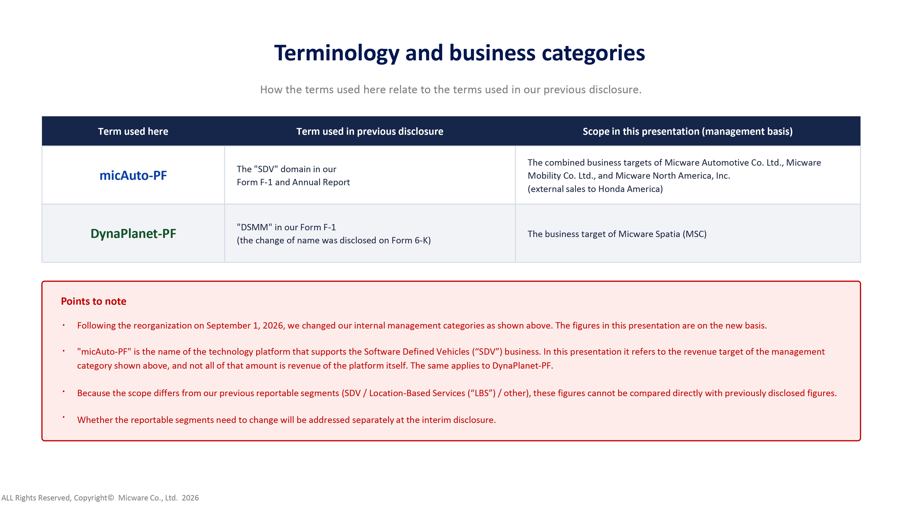
Terminology and business categories How the terms used here relate to the terms used in our previous disclosure. Term used here Term used in previous disclosure Scope in this presentation (management basis) micAuto - PF The "SDV" domain in our Form F - 1 and Annual Report The combined business targets of Micware Automotive Co. Ltd., Micware Mobility Co. Ltd., and Micware North America, Inc. (external sales to Honda America) DynaPlanet - PF "DSMM" in our Form F - 1 (the change of name was disclosed on Form 6 - K) The business target of Micware Spatia (MSC) Points to note · Following the reorganization on September 1, 2026, we changed our internal management categories as shown above. The figures in this presentation are on the new basis. · "micAuto - PF" is the name of the technology platform that supports the Software Defined Vehicles (“SDV”) business. In this presen tation it refers to the revenue target of the management category shown above, and not all of that amount is revenue of the platform itself. The same applies to DynaPlanet - PF. · Because the scope differs from our previous reportable segments (SDV / Location - Based Services (“LBS”) / other), these figures c annot be compared directly with previously disclosed figures. · Whether the reportable segments need to change will be addressed separately at the interim disclosure. ALL Rights Reserved, Copyright© Micware Co., Ltd. 2026
3

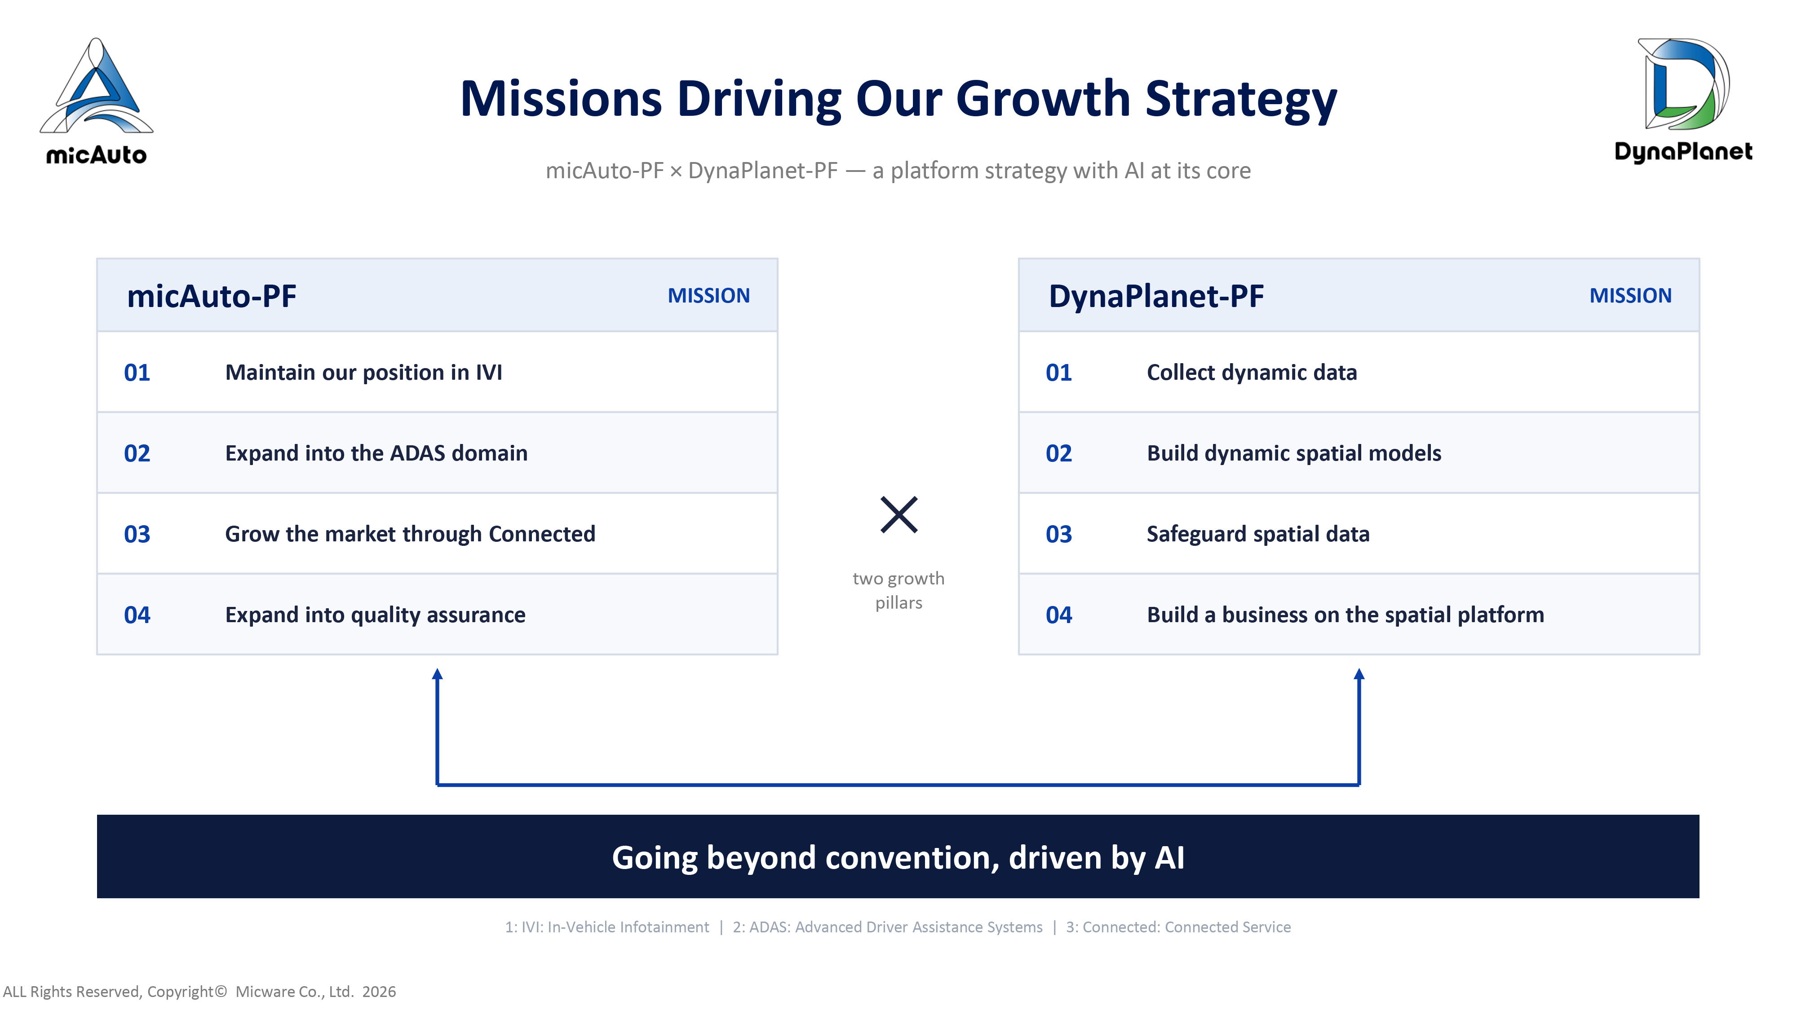
Missions Driving Our Growth Strategy micAuto - PF × DynaPlanet - PF — a platform strategy with AI at its core micAuto - PF MISSION 01 Maintain our position in IVI 02 Expand into the ADAS domain 03 Grow the market through Connected 04 Expand into quality assurance DynaPlanet - PF MISSION 01 Collect dynamic data 02 Build dynamic spatial models 03 Safeguard spatial data 04 Build a business on the spatial platform ✕ two growth pillars Going beyond convention, driven by AI 1: IVI: In - Vehicle Infotainment | 2: ADAS: Advanced Driver Assistance Systems | 3: Connected: Connected Service ALL Rights Reserved, Copyright© Micware Co., Ltd. 2026
4

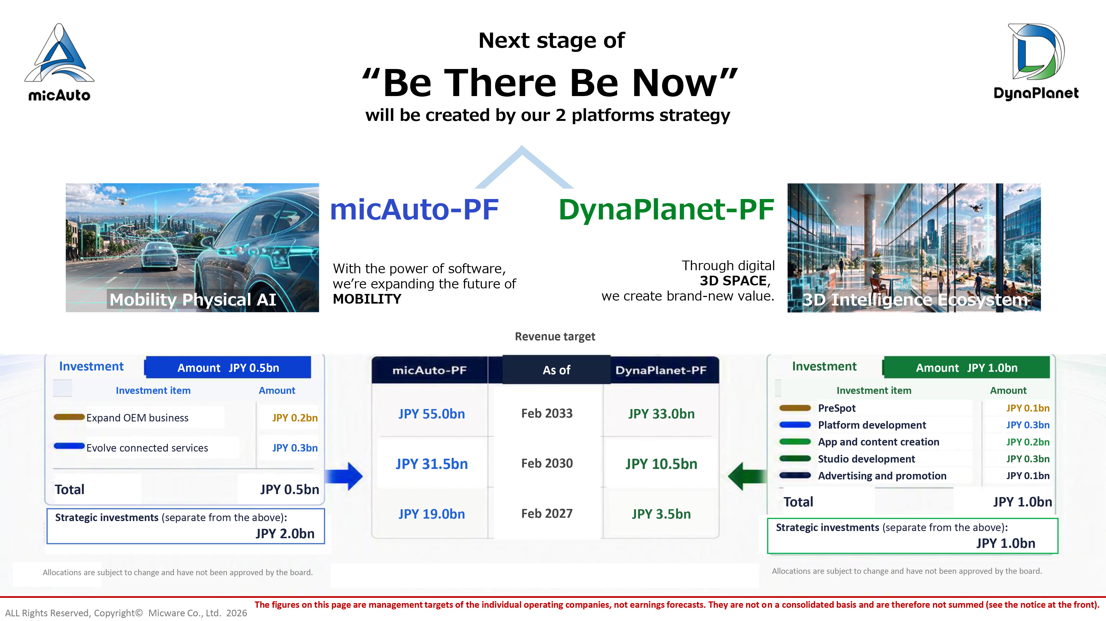
Next stage of “Be There Be Now” will be created by our 2 platforms strategy micAuto - PF DynaPlanet - PF With the power of software, we ’ re expanding the future of MOBILITY Through digital 3D SPACE , we create brand - new value. Mobility Physical AI 3D Intelligence Ecosystem Revenue target Investment Amount JPY 0.5bn Investment item Amount Expand OEM business JPY 0.2bn Evolve connected services JPY 0.3bn Total JPY 0.5bn As of JPY 55.0bn Feb 2033 JPY 33.0bn JPY 31.5bn Feb 2030 JPY 10.5bn JPY 19.0bn Feb 2027 JPY 3.5bn Investment Amount JPY 1.0bn Investment item Amount PreSpot Platform development App and content creation Studio development Advertising and promotion JPY 0.1bn JPY 0.3bn JPY 0.2bn JPY 0.3bn JPY 0.1bn Total JPY 1.0bn The figures on this page are management targets of the individual operating companies, not earnings forecasts. They are not o n a consolidated basis and are therefore not summed (see the notice at the front). ALL Rights Reserved, Copyright© Micware Co., Ltd. 2026 Strategic investments (separate from the above) : JPY 2.0bn Allocations are subject to change and have not been approved by the board. Allocations are subject to change and have not been approved by the board. Strategic investments (separate from the above) : JPY 1.0bn
5

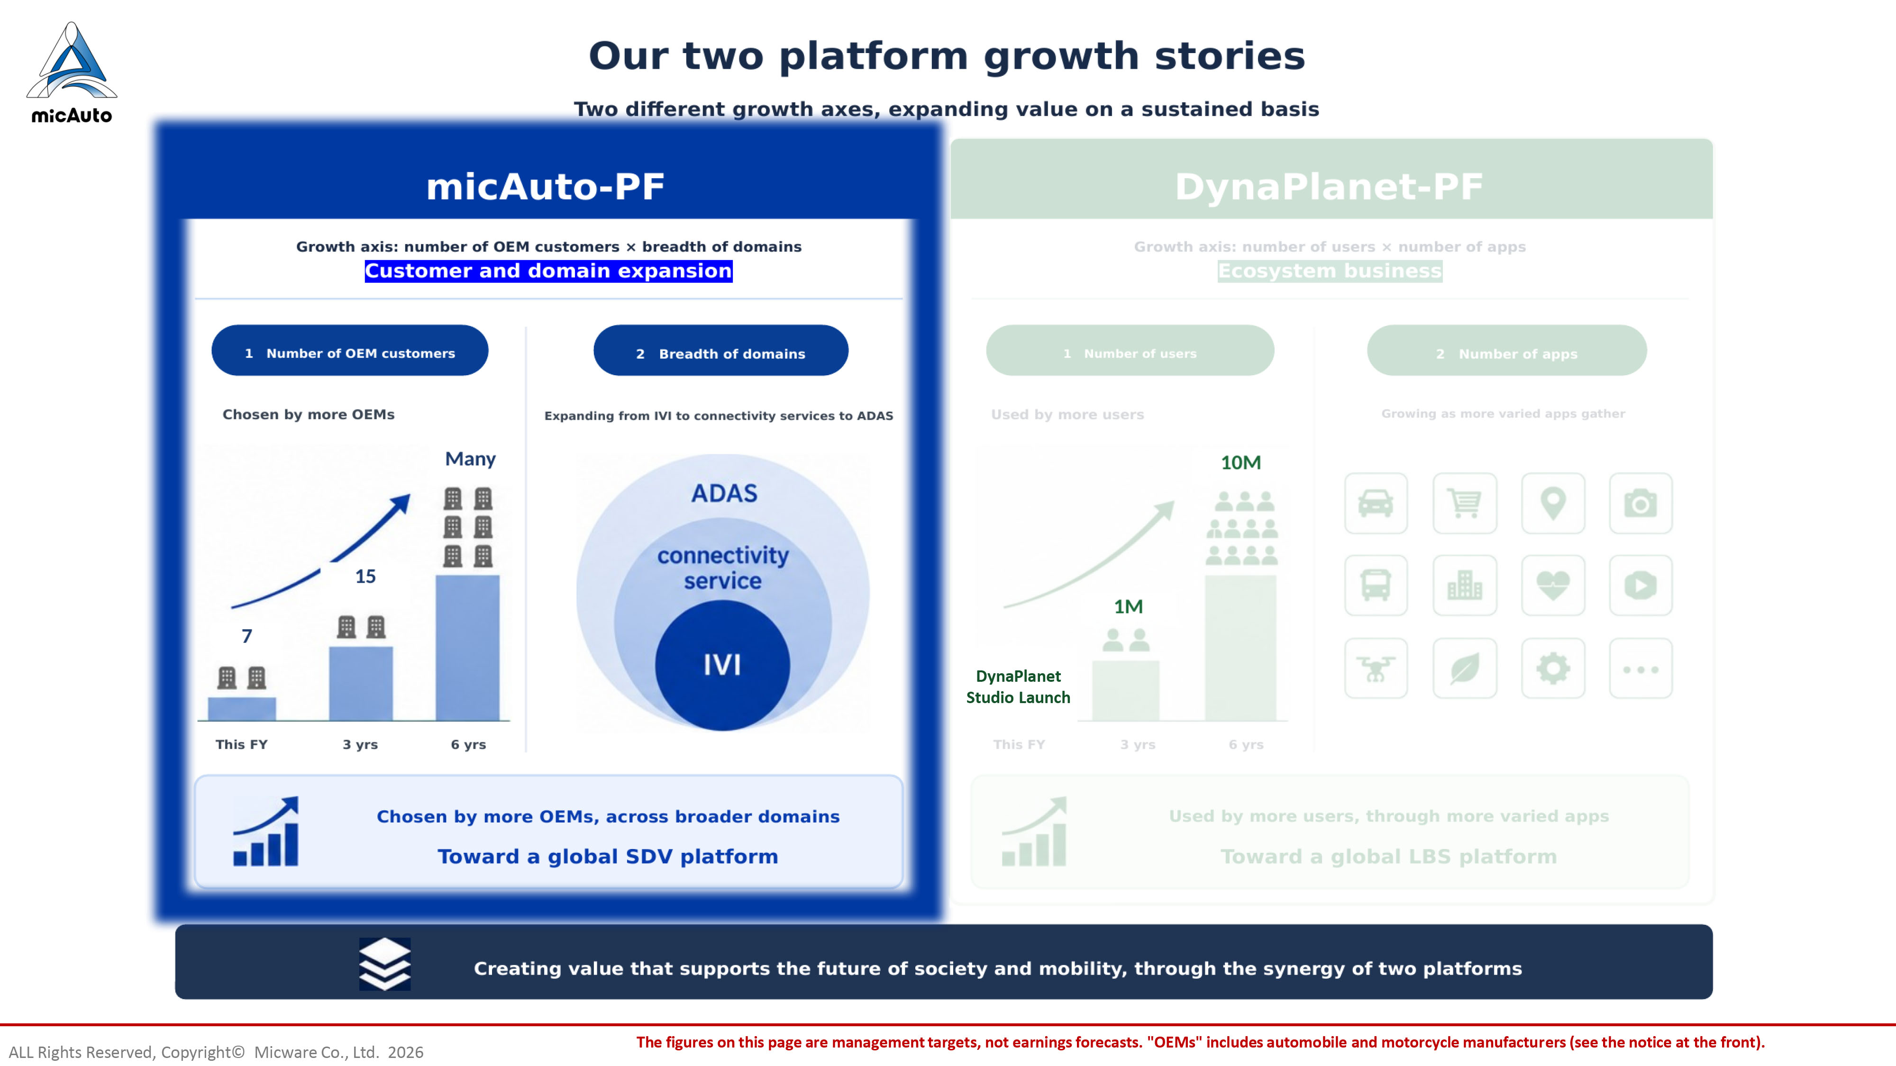
The figures on this page are management targets, not earnings forecasts. "OEMs" includes automobile and motorcycle manufactur ers (see the notice at the front). ALL Rights Reserved, Copyright© Micware Co., Ltd. 2026 DynaPlanet Studio Launch
6

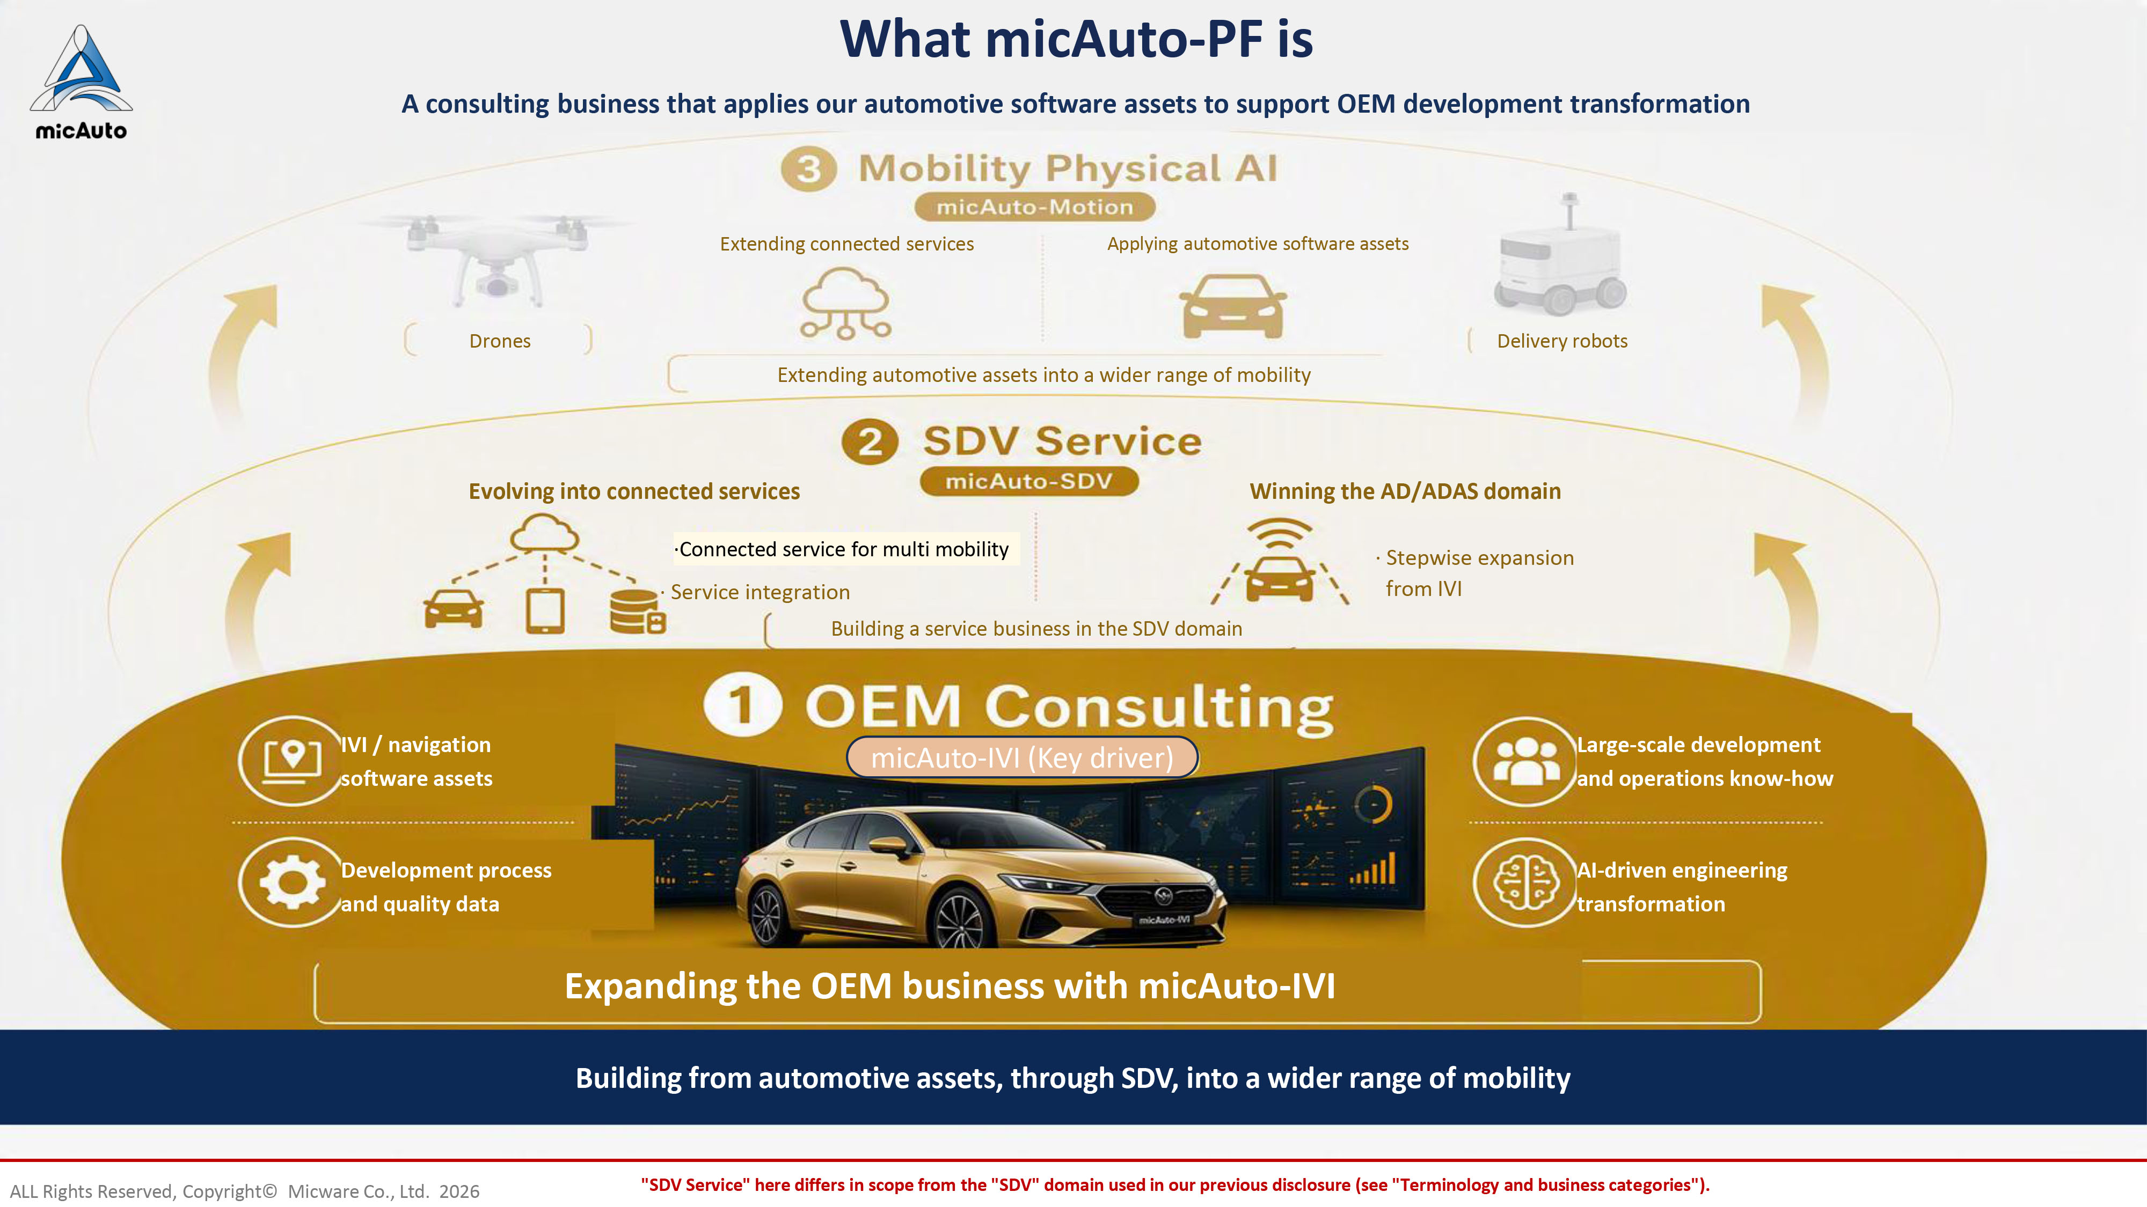
What micAuto - PF is A consulting business that applies our automotive software assets to support OEM development transformation Extending connected services Applying automotive software assets Drones Delivery robots Extending automotive assets into a wider range of mobility Evolving into connected services Winning the AD/ADAS domain · Service integration · Stepwise expansion from IVI Building a service business in the SDV domain IVI / navigation software assets Development process and quality data Large - scale development and operations know - how AI - driven engineering transformation Expanding the OEM business with micAuto - IVI Building from automotive assets, through SDV, into a wider range of mobility · Stepwise expansion from IVI "SDV Service" here differs in scope from the "SDV" domain used in our previous disclosure (see "Terminology and business cate gor ies"). ALL Rights Reserved, Copyright© Micware Co., Ltd. 2026 micAuto - IVI (Key driver) ·Connected service for multi mobility
7

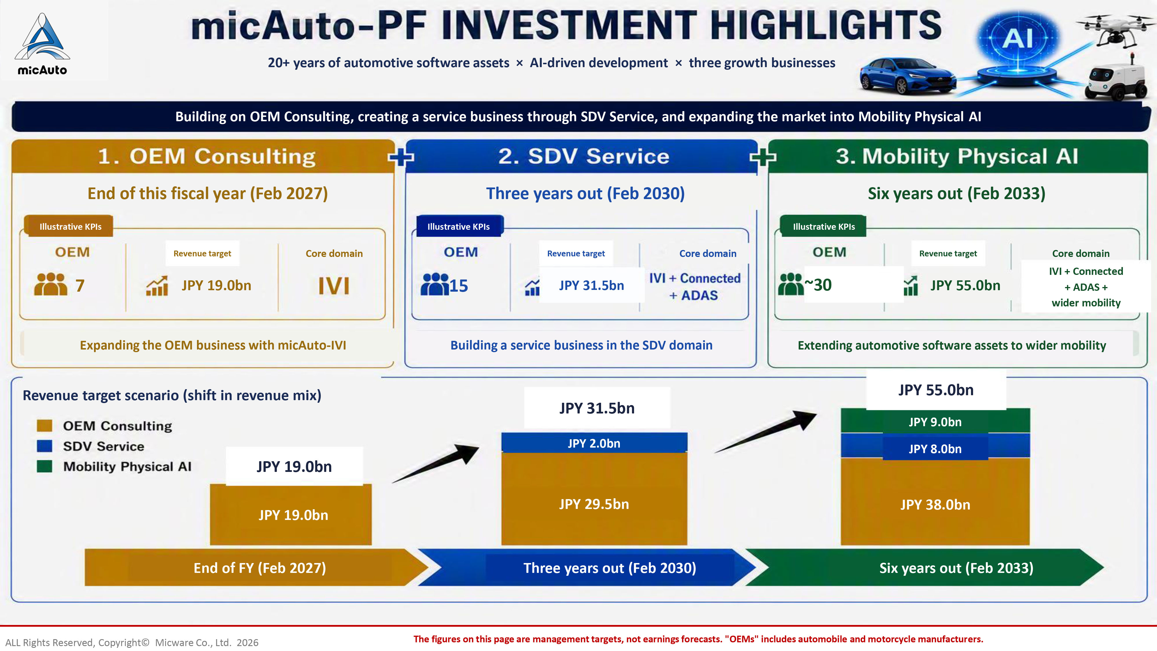
20+ years of automotive software assets × AI - driven development × three growth businesses Building on OEM Consulting, creating a service business through SDV Service, and expanding the market into Mobility Physical AI End of this fiscal year (Feb 2027) Three years out (Feb 2030) Six years out (Feb 2033) Illustrative KPIs Illustrative KPIs Illustrative KPIs Revenue target Revenue target Revenue target Core domain Core domain Core domain 7 JPY 19.0bn 15 JPY 31.5bn ~30 JPY 55.0bn IVI + Connected + ADAS + wider mobility Expanding the OEM business with micAuto - IVI Building a service business in the SDV domain Extending automotive software assets to wider mobility Revenue target scenario (shift in revenue mix) JPY 19.0bn JPY 31.5bn JPY 55.0bn JPY 19.0bn JPY 2.0bn JPY 29.5bn JPY 9.0bn JPY 8.0bn JPY 38.0bn End of FY (Feb 2027) Three years out (Feb 2030) Six years out (Feb 2033) The figures on this page are management targets, not earnings forecasts. "OEMs" includes automobile and motorcycle manufactur ers . ALL Rights Reserved, Copyright© Micware Co., Ltd. 2026
8

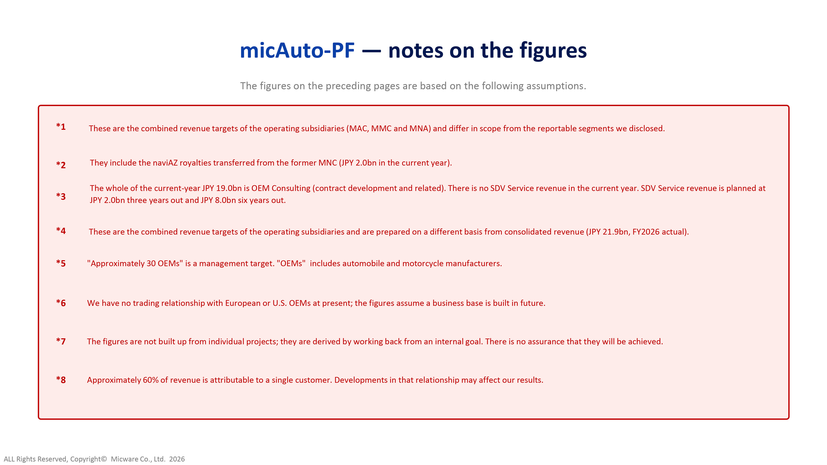
micAuto - PF — notes on the figures The figures on the preceding pages are based on the following assumptions. *1 These are the combined revenue targets of the operating subsidiaries (MAC, MMC and MNA) and differ in scope from the reportab le segments we disclosed. *2 They include the naviAZ royalties transferred from the former MNC (JPY 2.0bn in the current year). *3 The whole of the current - year JPY 19.0bn is OEM Consulting (contract development and related). There is no SDV Service revenue i n the current year. SDV Service revenue is planned at JPY 2.0bn three years out and JPY 8.0bn six years out. *4 These are the combined revenue targets of the operating subsidiaries and are prepared on a different basis from consolidated rev enue (JPY 21.9bn, FY2026 actual). *5 "Approximately 30 OEMs" is a management target. "OEMs" includes automobile and motorcycle manufacturers. *6 We have no trading relationship with European or U.S. OEMs at present; the figures assume a business base is built in future. *7 The figures are not built up from individual projects; they are derived by working back from an internal goal. There is no as sur ance that they will be achieved. *8 Approximately 60% of revenue is attributable to a single customer. Developments in that relationship may affect our results. ALL Rights Reserved, Copyright© Micware Co., Ltd. 2026
9

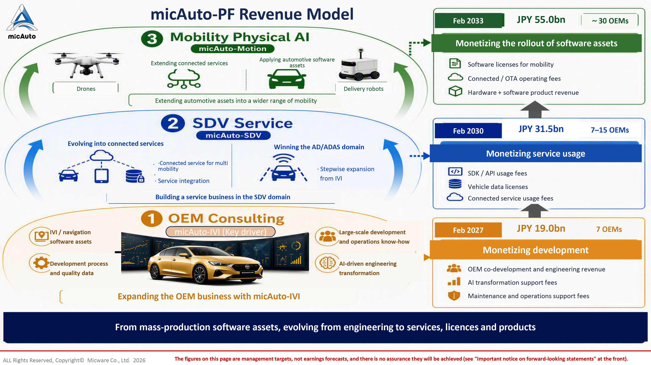
micAuto - PF Revenue Model Extending connected services Applying automotive software assets Drones Delivery robots Extending automotive assets into a wider range of mobility Evolving into connected services Winning the AD/ADAS domain · Service integration · Stepwise expansion from IVI Building a service business in the SDV domain IVI / navigation software assets Development process and quality data Large - scale development and operations know - how AI - driven engineering transformation Expanding the OEM business with micAuto - IVI Feb 2033 JPY 55.0bn ～ 30 OEMs Monetizing the rollout of software assets Software licenses for mobility Connected / OTA operating fees Hardware + software product revenue Feb 2030 JPY 31.5bn 7 – 15 OEMs Monetizing service usage SDK / API usage fees Vehicle data licenses Connected service usage fees Feb 2027 JPY 19.0bn 7 OEMs Monetizing development OEM co - development and engineering revenue AI transformation support fees Maintenance and operations support fees From mass - production software assets, evolving from engineering to services, licences and products The figures on this page are management targets, not earnings forecasts, and there is no assurance they will be achieved (see "I mportant notice on forward - looking statements" at the front). ALL Rights Reserved, Copyright© Micware Co., Ltd. 2026 micAuto - IVI (Key driver) · ·Connected service for multi mobility
10

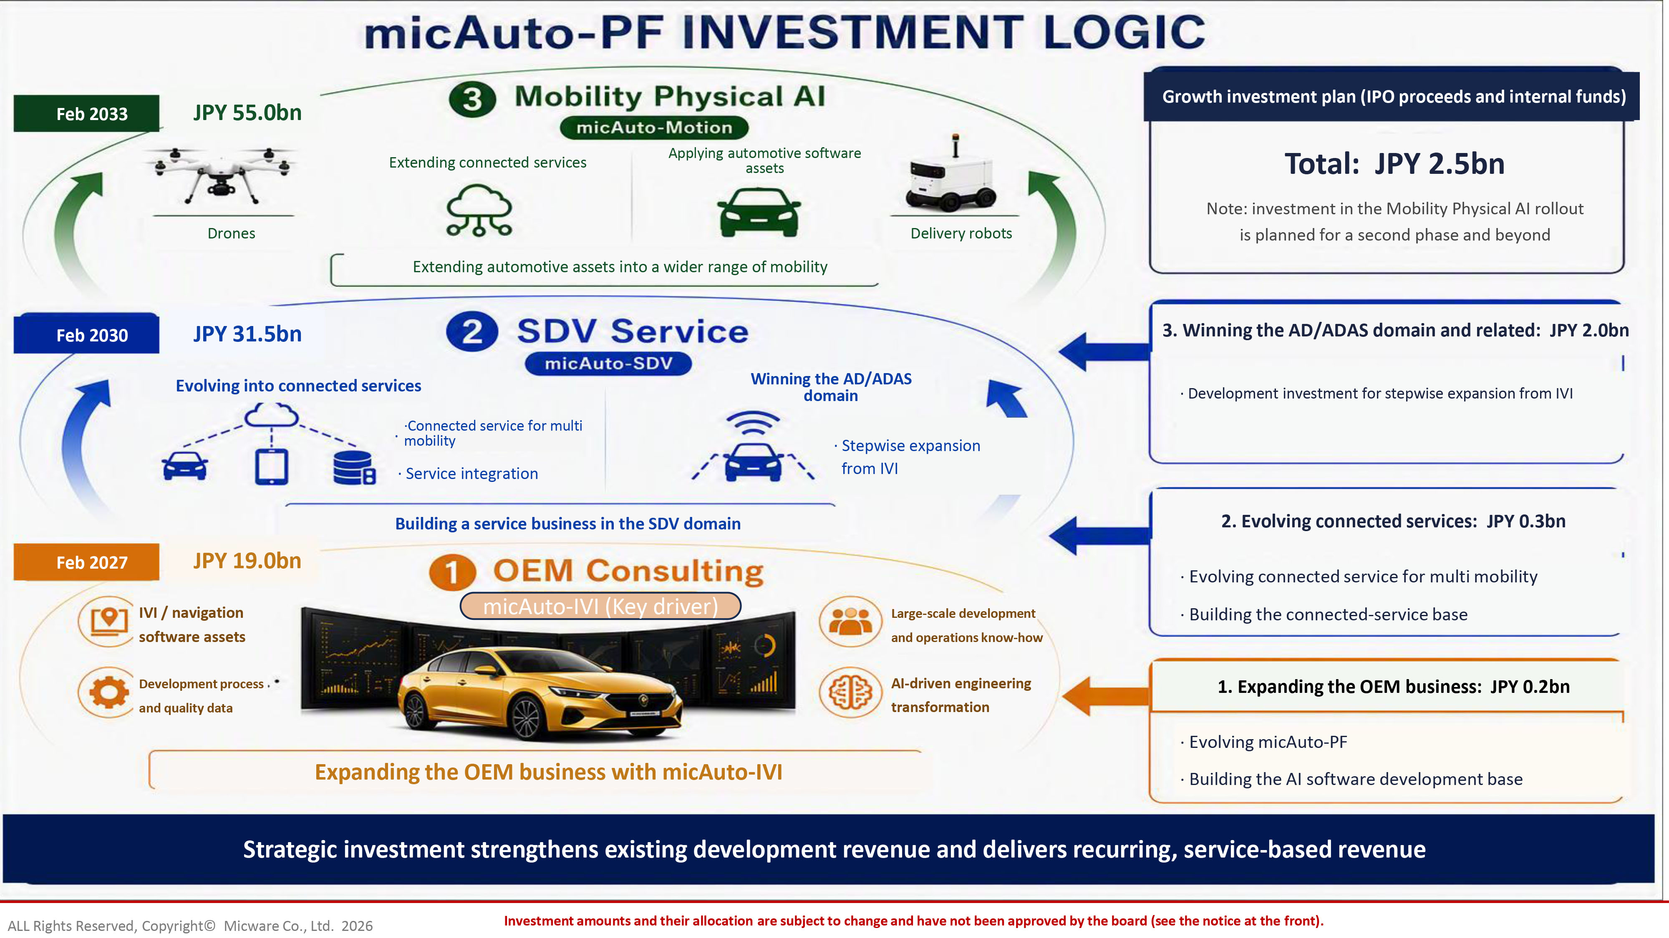
Feb 2033 JPY 55.0bn Extending connected services Applying automotive software assets Drones Delivery robots Extending automotive assets into a wider range of mobility Feb 2030 JPY 31.5bn Evolving into connected services Winning the AD/ADAS domain · Service integration · Stepwise expansion from IVI Building a service business in the SDV domain Feb 2027 JPY 19.0bn IVI / navigation software assets Development process and quality data Large - scale development and operations know - how AI - driven engineering transformation Expanding the OEM business with micAuto - IVI Growth investment plan (IPO proceeds and internal funds) Total: JPY 2.5bn Note: investment in the Mobility Physical AI rollout is planned for a second phase and beyond 3. Winning the AD/ADAS domain and related: JPY 2.0bn · Development investment for stepwise expansion from IVI 2. Evolving connected services: JPY 0.3bn · Evolving c onnected service for multi mobility · Building the connected - service base 1. Expanding the OEM business: JPY 0.2bn · Evolving micAuto - PF · Building the AI software development base Strategic investment strengthens existing development revenue and delivers recurring, service - based revenue Growth investment plan (IPO proceeds and internal funds) · Stepwise expansion from IVI Investment amounts and their allocation are subject to change and have not been approved by the board (see the notice at the fro nt). ALL Rights Reserved, Copyright© Micware Co., Ltd. 2026 micAuto - IVI (Key driver) · ·Connected service for multi mobility
11

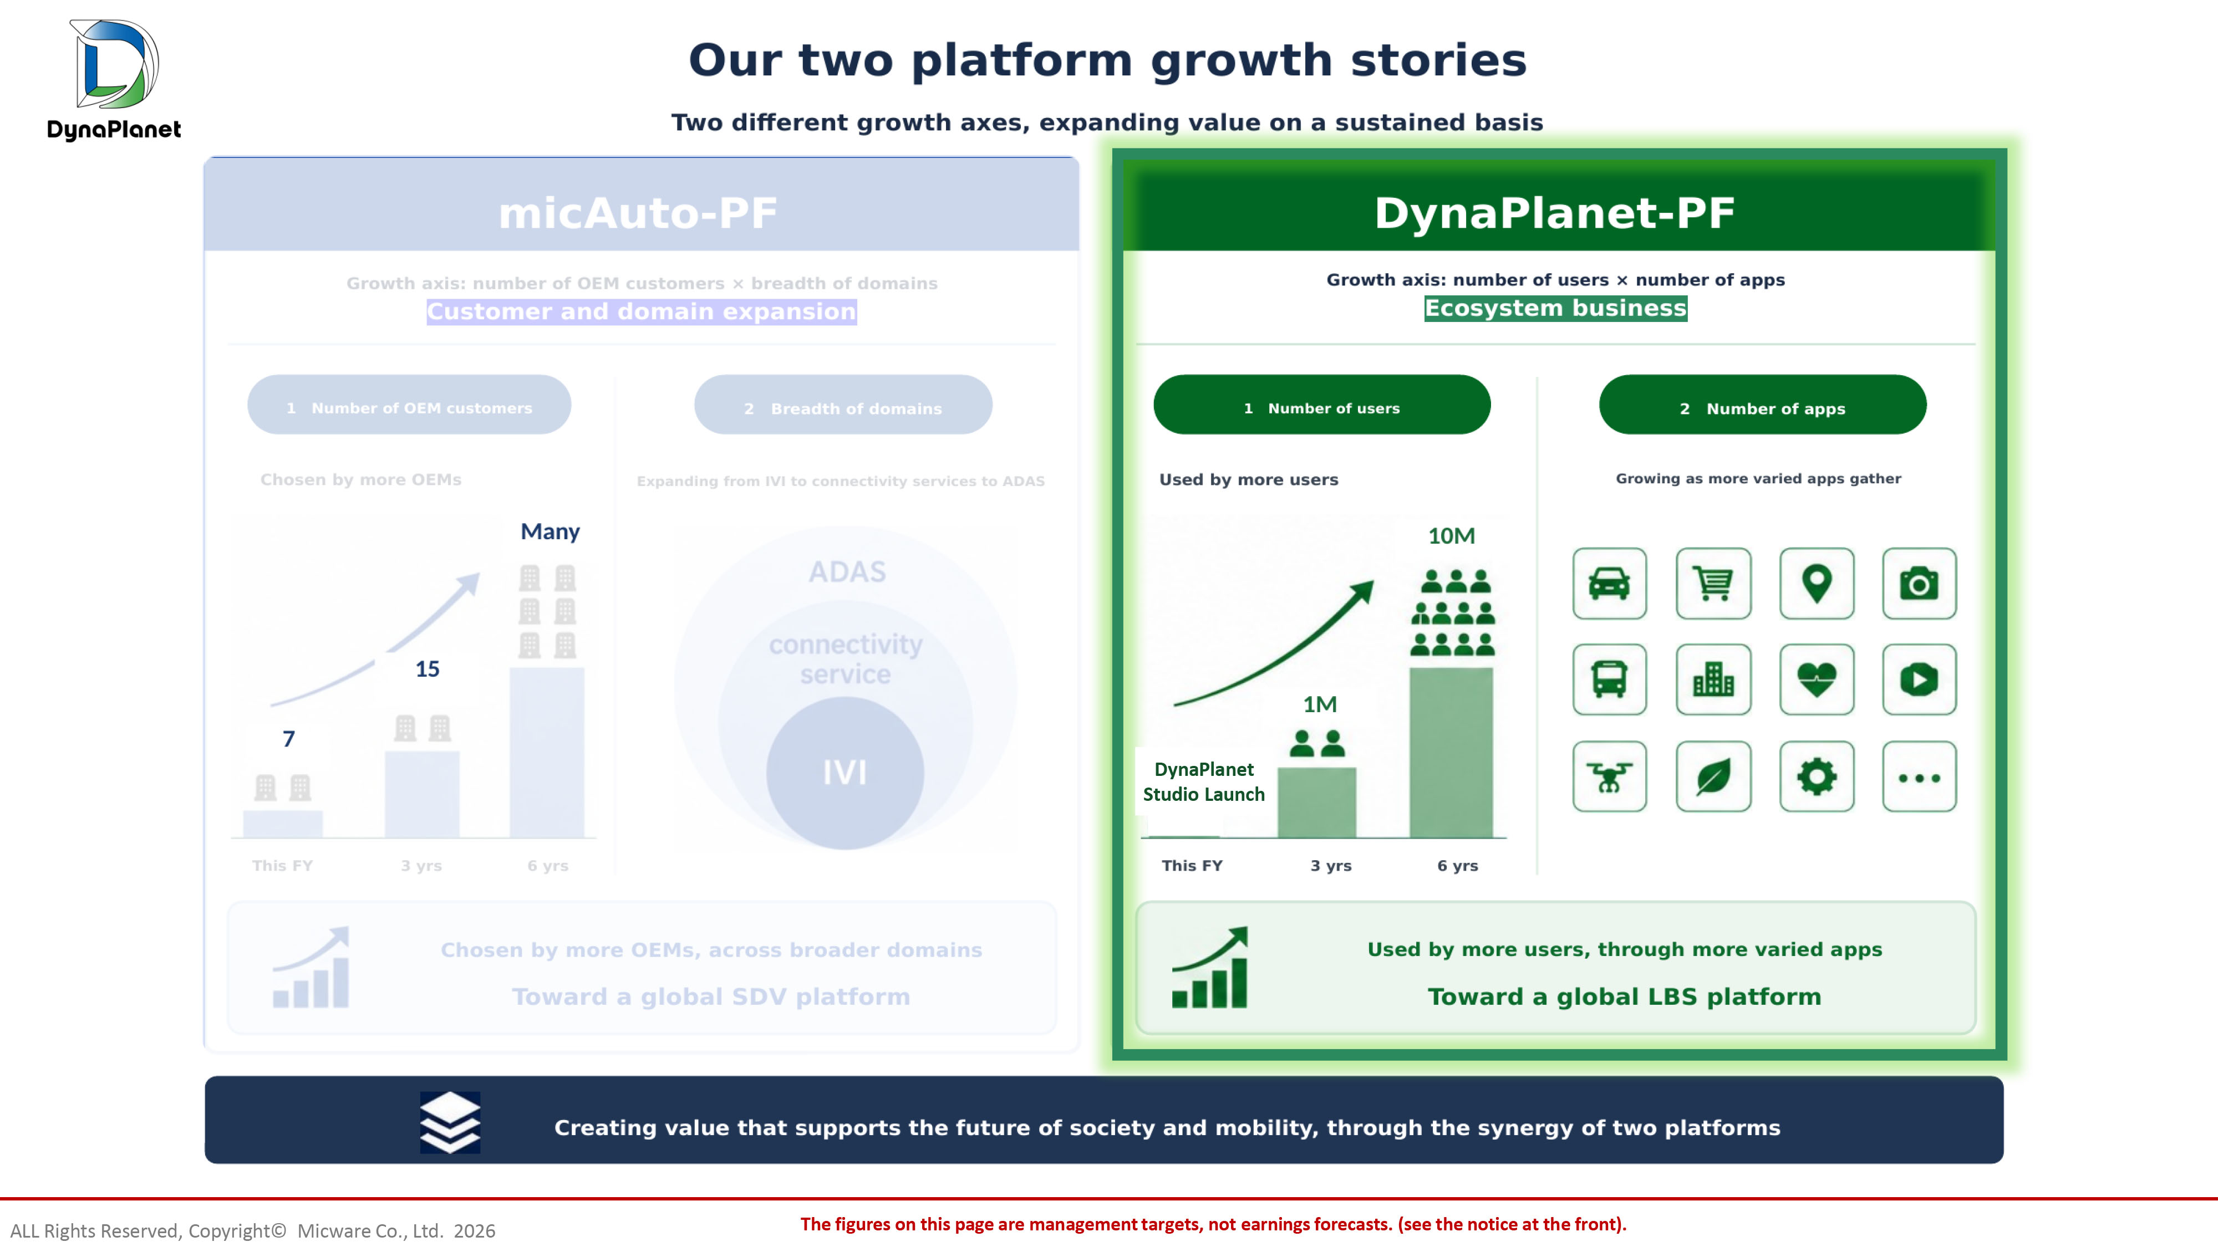
The figures on this page are management targets, not earnings forecasts. (see the notice at the front). ALL Rights Reserved, Copyright© Micware Co., Ltd. 2026 DynaPlanet Studio Launch
12

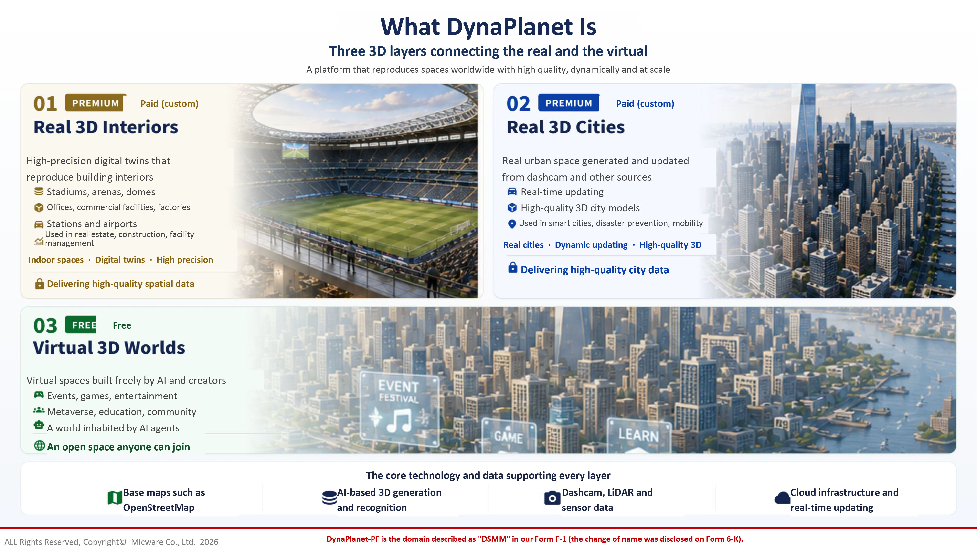
What DynaPlanet Is Three 3D layers connecting the real and the virtual A platform that reproduces spaces worldwide with high quality, dynamically and at scale Paid (custom) High - precision digital twins that reproduce building interiors Stadiums, arenas, domes Offices, commercial facilities, factories Stations and airports Used in real estate, construction, facility management Indoor spaces · Digital twins · High precision Delivering high - quality spatial data Paid (custom) Real urban space generated and updated from dashcam and other sources Real - time updating High - quality 3D city models Used in smart cities, disaster prevention, mobility Real cities · Dynamic updating · High - quality 3D Delivering high - quality city data Free Virtual spaces built freely by AI and creators Events, games, entertainment Metaverse, education, community A world inhabited by AI agents An open space anyone can join The core technology and data supporting every layer Base maps such as OpenStreetMap AI - based 3D generation and recognition Dashcam, LiDAR and sensor data Cloud infrastructure and real - time updating DynaPlanet - PF is the domain described as "DSMM" in our Form F - 1 (the change of name was disclosed on Form 6 - K). ALL Rights Reserved, Copyright© Micware Co., Ltd. 2026
13

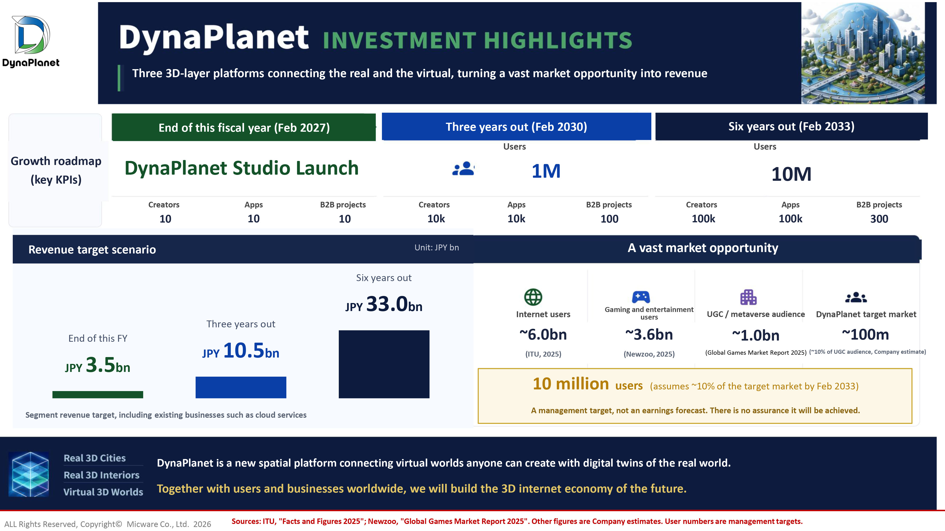
Three 3D - layer platforms connecting the real and the virtual, turning a vast market opportunity into revenue Growth roadmap (key KPIs) End of this fiscal year (Feb 2027) Three years out (Feb 2030) Six years out (Feb 2033) Users Users Users DynaPlanet Studio Launch 1M 10M Creators Apps B2B projects Creators Apps B2B projects Creators Apps B2B projects 10 10 10 10k 10k 100 100k 100k 300 A vast market opportunity Internet users Gaming and entertainment users UGC / metaverse audience DynaPlanet target market ~6.0bn ~3.6bn ~1.0bn ~100m (ITU, 2025) (Newzoo, 2025) ( Global Games Market Report 2025 ) (~10% of UGC audience, Company estimate) DynaPlanet is a new spatial platform connecting virtual worlds anyone can create with digital twins of the real world. Together with users and businesses worldwide, we will build the 3D internet economy of the future. Revenue target scenario Unit: JPY bn End of this FY JPY 3.5 bn Three years out JPY 10.5 bn Six years out JPY 33.0 bn Segment revenue target, including existing businesses such as cloud services 10 million users (assumes ~10% of the target market by Feb 2033) A management target, not an earnings forecast. There is no assurance it will be achieved. Sources: ITU, "Facts and Figures 2025"; Newzoo, "Global Games Market Report 2025". Other figures are Company estimates. User num bers are management targets. ALL Rights Reserved, Copyright© Micware Co., Ltd. 2026
14

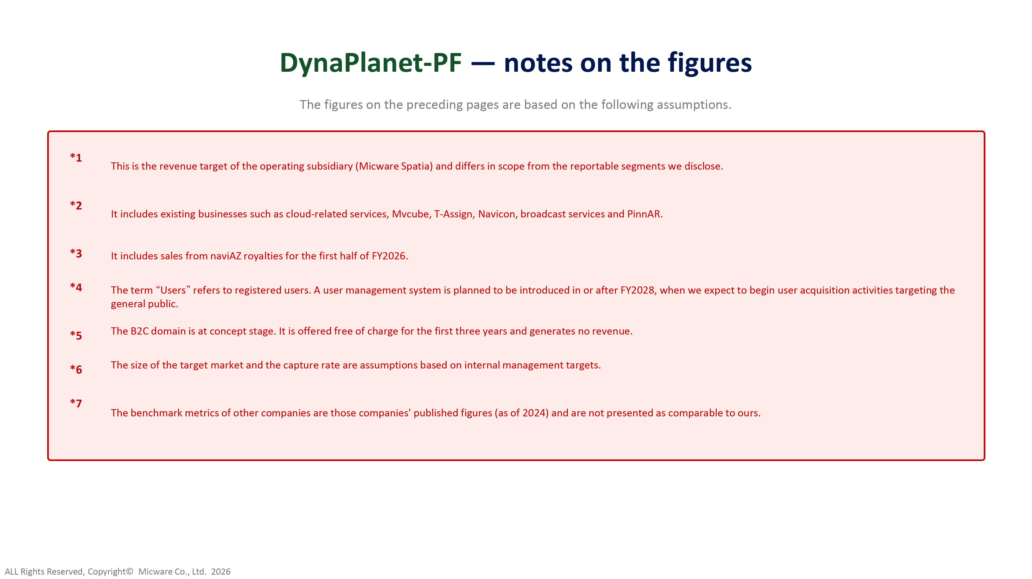
DynaPlanet - PF — notes on the figures The figures on the preceding pages are based on the following assumptions. *1 This is the revenue target of the operating subsidiary (Micware Spatia) and differs in scope from the reportable segments we dis close. *2 It includes existing businesses such as cloud - related services, Mvcube , T - Assign, Navicon , broadcast services and PinnAR . *3 It includes sales from naviAZ royalties for the first half of FY2026. *4 *5 The term “ Users ” refers to registered users. A user management system is planned to be introduced in or after FY2028, when we expect to begin us er acquisition activities targeting the general public. *6 The B2C domain is at concept stage. It is offered free of charge for the first three years and generates no revenue. *7 The size of the target market and the capture rate are assumptions based on internal management targets. The benchmark metrics of other companies are those companies' published figures (as of 2024) and are not presented as compara ble to ours. ALL Rights Reserved, Copyright© Micware Co., Ltd. 2026
15

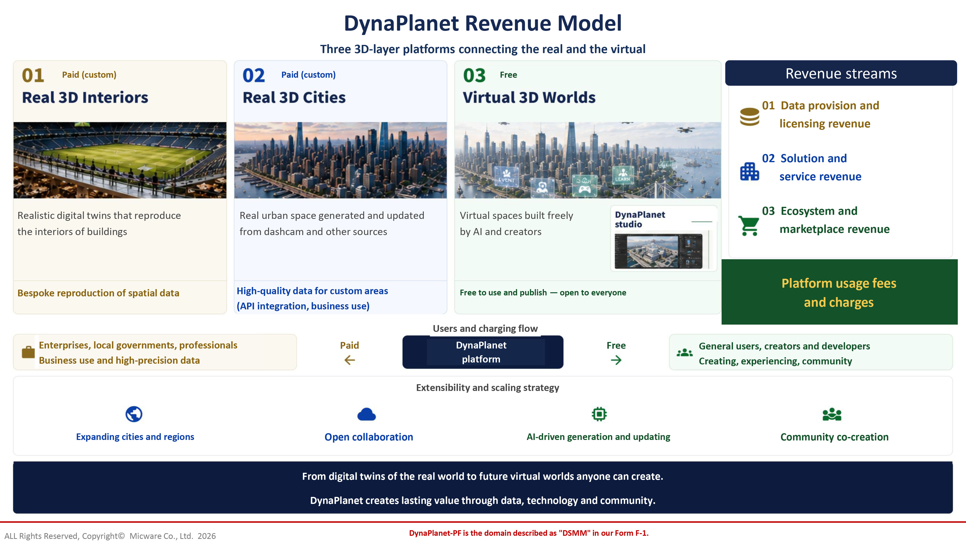
DynaPlanet Revenue Model Three 3D - layer platforms connecting the real and the virtual Paid (custom) Paid (custom) Free Realistic digital twins that reproduce the interiors of buildings Real urban space generated and updated from dashcam and other sources Virtual spaces built freely by AI and creators Free Bespoke reproduction of spatial data High - quality data for custom areas (API integration, business use) Free to use and publish — open to everyone 01 Data provision and licensing revenue 02 Solution and service revenue 03 Ecosystem and marketplace revenue Users and charging flow Enterprises, local governments, professionals Business use and high - precision data Paid Free DynaPlanet platform General users, creators and developers Creating, experiencing, community Extensibility and scaling strategy Expanding cities and regions Open collaboration AI - driven generation and updating Community co - creation From digital twins of the real world to future virtual worlds anyone can create. DynaPlanet creates lasting value through data, technology and community. Platform usage fees and charges DynaPlanet - PF is the domain described as "DSMM" in our Form F - 1. ALL Rights Reserved, Copyright© Micware Co., Ltd. 2026 Revenue streams
16

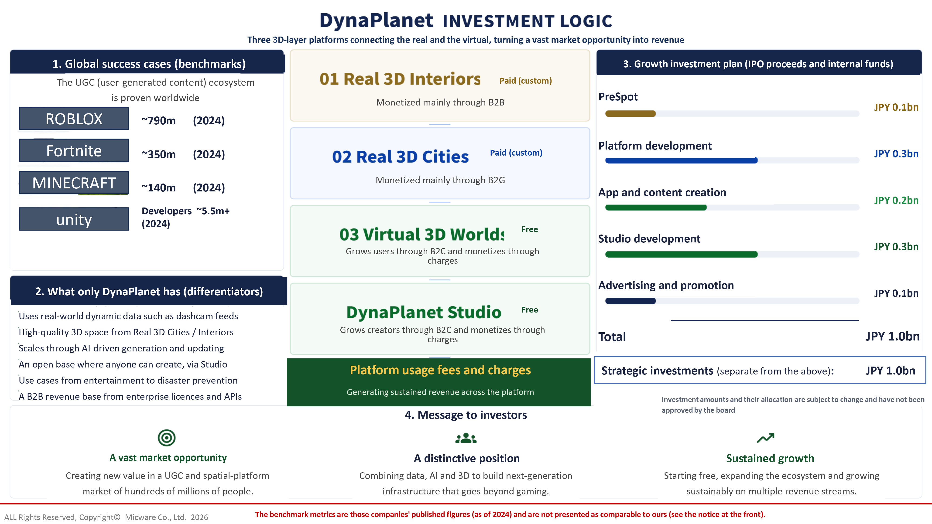
Three 3D - layer platforms connecting the real and the virtual, turning a vast market opportunity into revenue 1. Global success cases (benchmarks) The UGC (user - generated content) ecosystem is proven worldwide ~790m (2024) ~350m (2024) ~140m (2024) Developers ~5.5m+ (2024) 2. What only DynaPlanet has (differentiators) Uses real - world dynamic data such as dashcam feeds High - quality 3D space from Real 3D Cities / Interiors Scales through AI - driven generation and updating An open base where anyone can create, via Studio Use cases from entertainment to disaster prevention A B2B revenue base from enterprise licences and APIs Paid (custom) Paid (custom) Free Free Monetized mainly through B2B Monetized mainly through B2G Grows users through B2C and monetizes through charges Grows creators through B2C and monetizes through charges PreSpot Platform development App and content creation Studio development Advertising and promotion JPY 0.1bn JPY 0.3bn JPY 0.2bn JPY 0.3bn JPY 0.1bn Total JPY 1.0bn 4. Message to investors A vast market opportunity A distinctive position Sustained growth Creating new value in a UGC and spatial - platform market of hundreds of millions of people. Combining data, AI and 3D to build next - generation infrastructure that goes beyond gaming. Starting free, expanding the ecosystem and growing sustainably on multiple revenue streams. Platform usage fees and charges Generating sustained revenue across the platform 3. Growth investment plan (IPO proceeds and internal funds) Investment amounts and their allocation are subject to change and have not been approved by the board The benchmark metrics are those companies' published figures (as of 2024) and are not presented as comparable to ours (see th e n otice at the front). ALL Rights Reserved, Copyright© Micware Co., Ltd. 2026 ROBLOX Fortnite MINECRAFT unity Strategic investments (separate from the above) : JPY 1.0bn
17

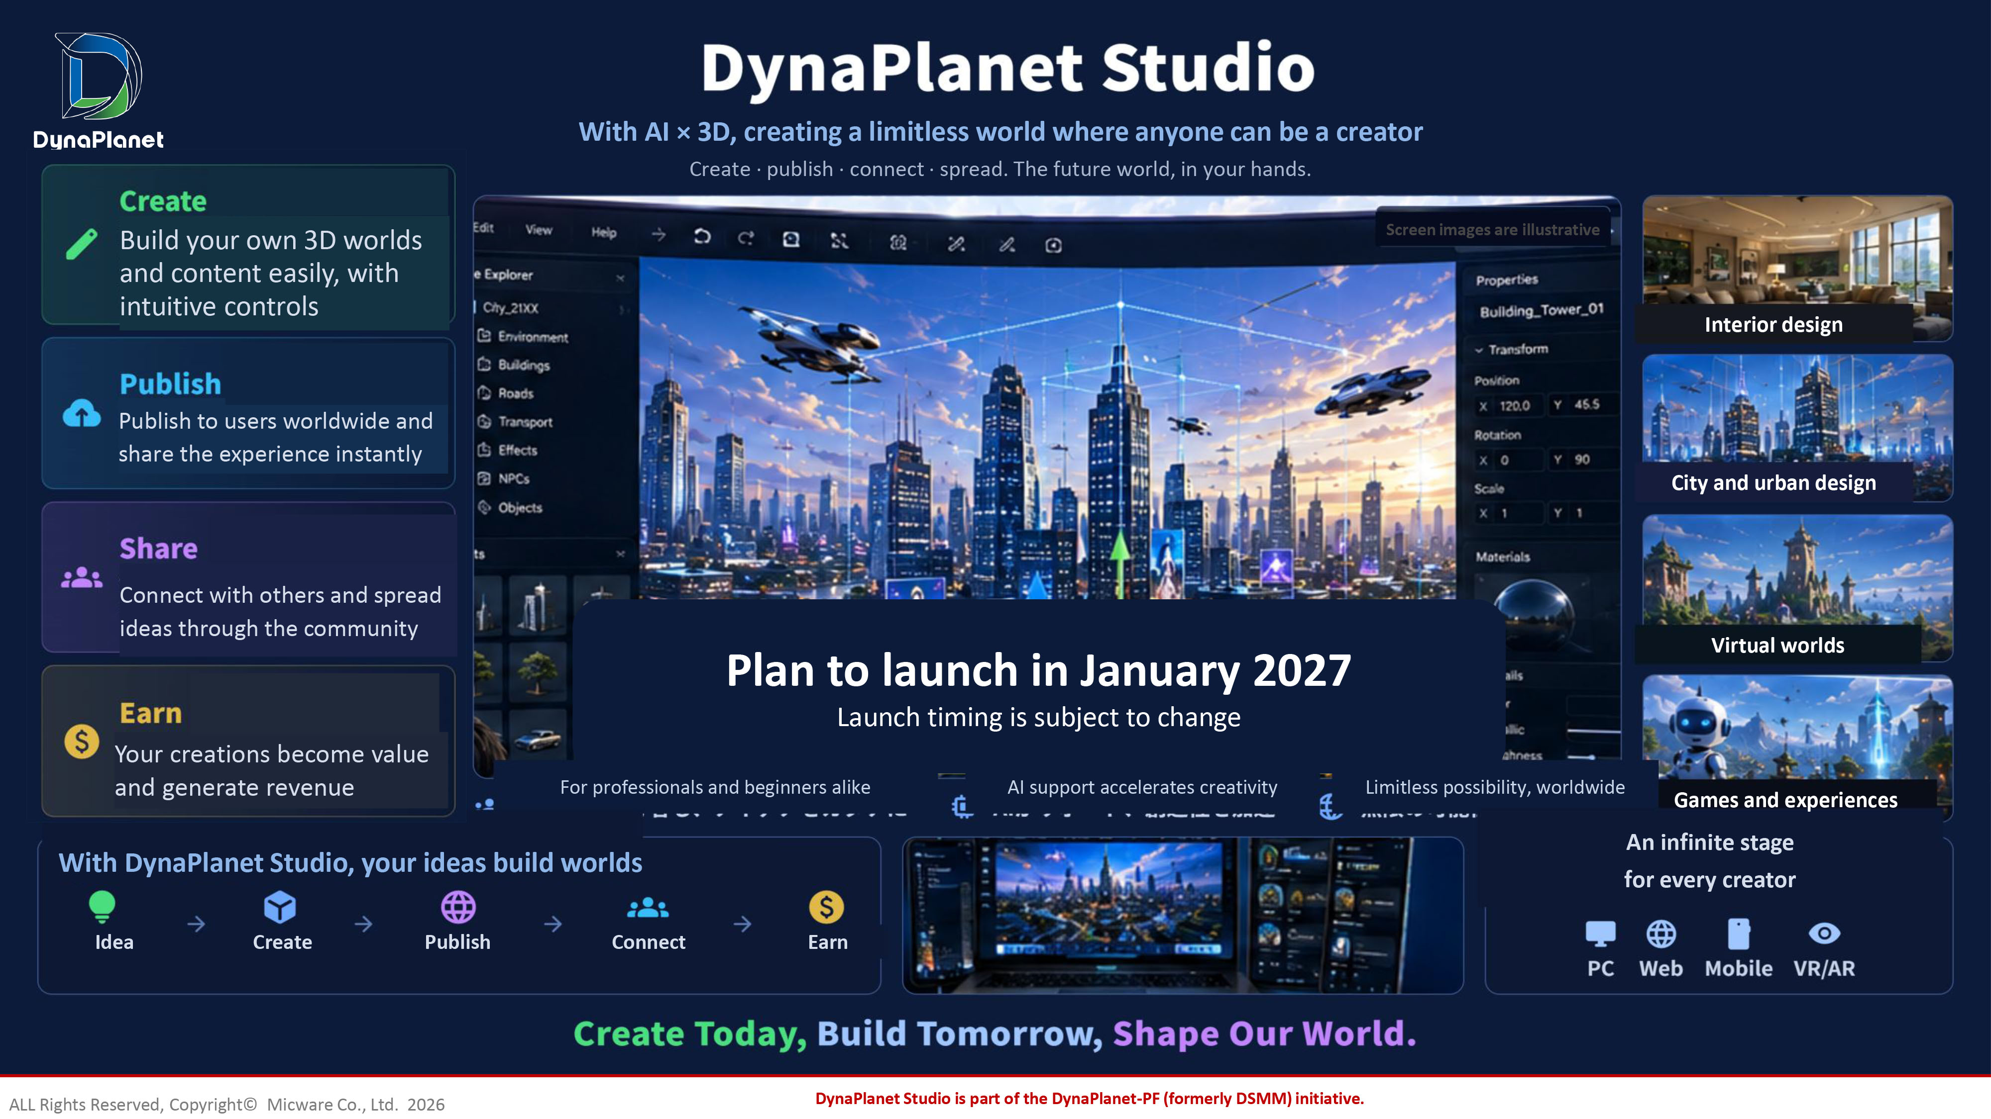
With AI × 3D, creating a limitless world where anyone can be a creator Create · publish · connect · spread. The future world, in your hands. Create Build your own 3D worlds and content easily, with intuitive controls Publish Publish to users worldwide and share the experience instantly Share Connect with others and spread ideas through the community Earn Your creations become value and generate revenue Screen images are illustrative Interior design City and urban design Virtual worlds Games and experiences For professionals and beginners alike AI support accelerates creativity Limitless possibility, worldwide With DynaPlanet Studio, your ideas build worlds Idea Create Publish Connect Earn An infinite stage for every creator DynaPlanet Studio is part of the DynaPlanet - PF (formerly DSMM) initiative. ALL Rights Reserved, Copyright© Micware Co., Ltd. 2026 Plan to launch in January 2027 Launch timing is subject to change Build your own 3D worlds and content easily, with intuitive controls Publish to users worldwide and share the experience instantly Connect with others and spread ideas through the community Your creations become value and generate revenue
18

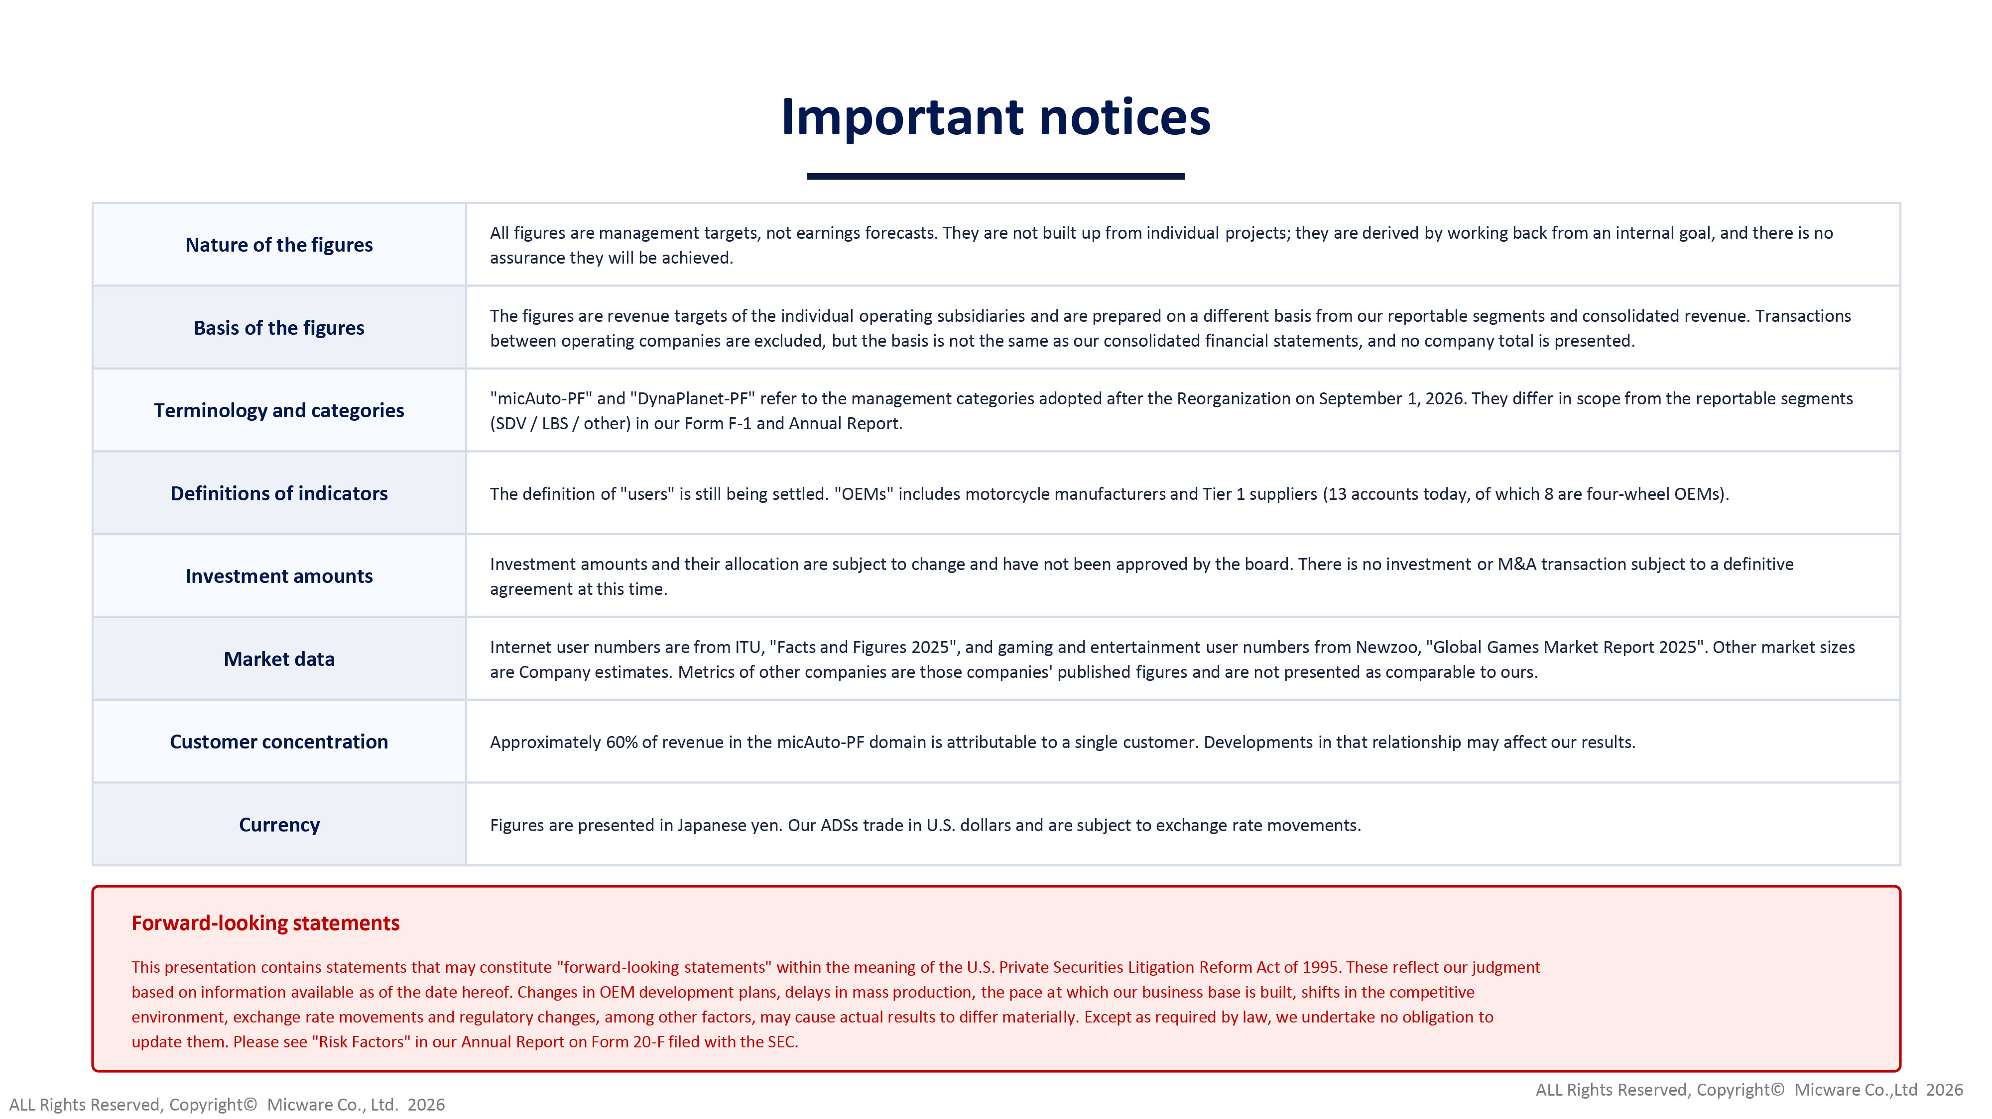
Important notices Nature of the figures All figures are management targets, not earnings forecasts. They are not built up from individual projects; they are derived by working back from an internal goal, and there is no assurance they will be achieved. Basis of the figures The figures are revenue targets of the individual operating subsidiaries and are prepared on a different basis from our repor tab le segments and consolidated revenue. Transactions between operating companies are excluded, but the basis is not the same as our consolidated financial statements, and no comp any total is presented. Terminology and categories " micAuto - PF" and " DynaPlanet - PF" refer to the management categories adopted after the Reorganization on September 1, 2026. They differ in scope from the r ep ortable segments (SDV / LBS / other) in our Form F - 1 and Annual Report. Definitions of indicators The definition of "users" is still being settled. "OEMs" includes motorcycle manufacturers and Tier 1 suppliers (13 accounts tod ay, of which 8 are four - wheel OEMs). Investment amounts Investment amounts and their allocation are subject to change and have not been approved by the board. There is no investment or M&A transaction subject to a definitive agreement at this time. Market data Internet user numbers are from ITU, "Facts and Figures 2025", and gaming and entertainment user numbers from Newzoo, "Global Gam es Market Report 2025". Other market sizes are Company estimates. Metrics of other companies are those companies' published figures and are not presented as comparable to ours. Customer concentration Approximately 60% of revenue in the micAuto - PF domain is attributable to a single customer. Developments in that relationship may affect our results. Currency Figures are presented in Japanese yen. Our ADSs trade in U.S. dollars and are subject to exchange rate movements. Forward - looking statements This presentation contains statements that may constitute "forward - looking statements" within the meaning of the U.S. Private Se curities Litigation Reform Act of 1995. These reflect our judgment based on information available as of the date hereof. Changes in OEM development plans, delays in mass production, the pace a t w hich our business base is built, shifts in the competitive environment, exchange rate movements and regulatory changes, among other factors, may cause actual results to differ material ly. Except as required by law, we undertake no obligation to update them. Please see "Risk Factors" in our Annual Report on Form 20 - F filed with the SEC. ALL Rights Reserved, Copyright© Micware Co.,Ltd 2026 ALL Rights Reserved, Copyright© Micware Co., Ltd. 2026
19

